options =

[**TrainingOptionsSGDM**](matlab:helpPopup%20nnet.cnn.TrainingOptionsSGDM) with properties:

Momentum: 0

InitialLearnRate: 1.0000e-03

LearnRateSchedule: 'none'

LearnRateDropFactor: 0.1000

LearnRateDropPeriod: 5

L2Regularization: 1.0000e-04

GradientThresholdMethod: 'l2norm'

GradientThreshold: Inf

MaxEpochs: 300

MiniBatchSize: 20

Verbose: 1

VerboseFrequency: 50

ValidationData: [1×1 augmentedImageDatastore]

ValidationFrequency: 4000

ValidationPatience: Inf

Shuffle: 'every-epoch'

CheckpointPath: ''

ExecutionEnvironment: 'gpu'

WorkerLoad: []

OutputFcn: []

Plots: 'training-progress'

SequenceLength: 'longest'

SequencePaddingValue: 0

SequencePaddingDirection: 'right'

DispatchInBackground: 0

ResetInputNormalization: 1

Initializing input data normalization.

|======================================================================================================================|

| Epoch | Iteration | Time Elapsed | Mini-batch | Validation | Mini-batch | Validation | Base Learning |

| | | (hh:mm:ss) | Accuracy | Accuracy | Loss | Loss | Rate |

|======================================================================================================================|

| 1 | 1 | 00:00:03 | 25.00% | 22.73% | 2.1485 | 1.9841 | 0.0010 |

| 13 | 50 | 00:00:47 | 60.00% | | 1.5835 | | 0.0010 |

| 25 | 100 | 00:01:31 | 45.00% | | 1.7596 | | 0.0010 |

| 38 | 150 | 00:02:23 | 55.00% | | 1.3612 | | 0.0010 |

| 50 | 200 | 00:03:13 | 65.00% | | 1.1070 | | 0.0010 |

| 63 | 250 | 00:04:04 | 75.00% | | 0.7991 | | 0.0010 |

| 75 | 300 | 00:04:54 | 60.00% | | 1.2194 | | 0.0010 |

| 88 | 350 | 00:05:45 | 55.00% | | 1.0583 | | 0.0010 |

| 100 | 400 | 00:06:35 | 60.00% | | 1.2858 | | 0.0010 |

| 113 | 450 | 00:07:27 | 60.00% | | 0.8683 | | 0.0010 |

| 125 | 500 | 00:08:18 | 60.00% | | 0.9310 | | 0.0010 |

| 138 | 550 | 00:09:10 | 85.00% | | 0.6891 | | 0.0010 |

| 150 | 600 | 00:10:01 | 65.00% | | 0.8207 | | 0.0010 |

| 163 | 650 | 00:10:52 | 90.00% | | 0.4883 | | 0.0010 |

| 175 | 700 | 00:11:43 | 65.00% | | 0.5308 | | 0.0010 |

| 188 | 750 | 00:12:34 | 85.00% | | 0.4249 | | 0.0010 |

| 200 | 800 | 00:13:24 | 85.00% | | 0.3730 | | 0.0010 |

| 213 | 850 | 00:14:16 | 95.00% | | 0.1648 | | 0.0010 |

| 225 | 900 | 00:15:07 | 95.00% | | 0.2355 | | 0.0010 |

| 238 | 950 | 00:16:00 | 95.00% | | 0.1301 | | 0.0010 |

| 250 | 1000 | 00:16:51 | 100.00% | | 0.2237 | | 0.0010 |

| 263 | 1050 | 00:17:45 | 85.00% | | 0.3921 | | 0.0010 |

| 275 | 1100 | 00:18:37 | 90.00% | | 0.3603 | | 0.0010 |

| 288 | 1150 | 00:19:30 | 100.00% | | 0.0418 | | 0.0010 |

| 300 | 1200 | 00:20:23 | 90.00% | 77.27% | 0.1950 | 0.4409 | 0.0010 |

|======================================================================================================================|

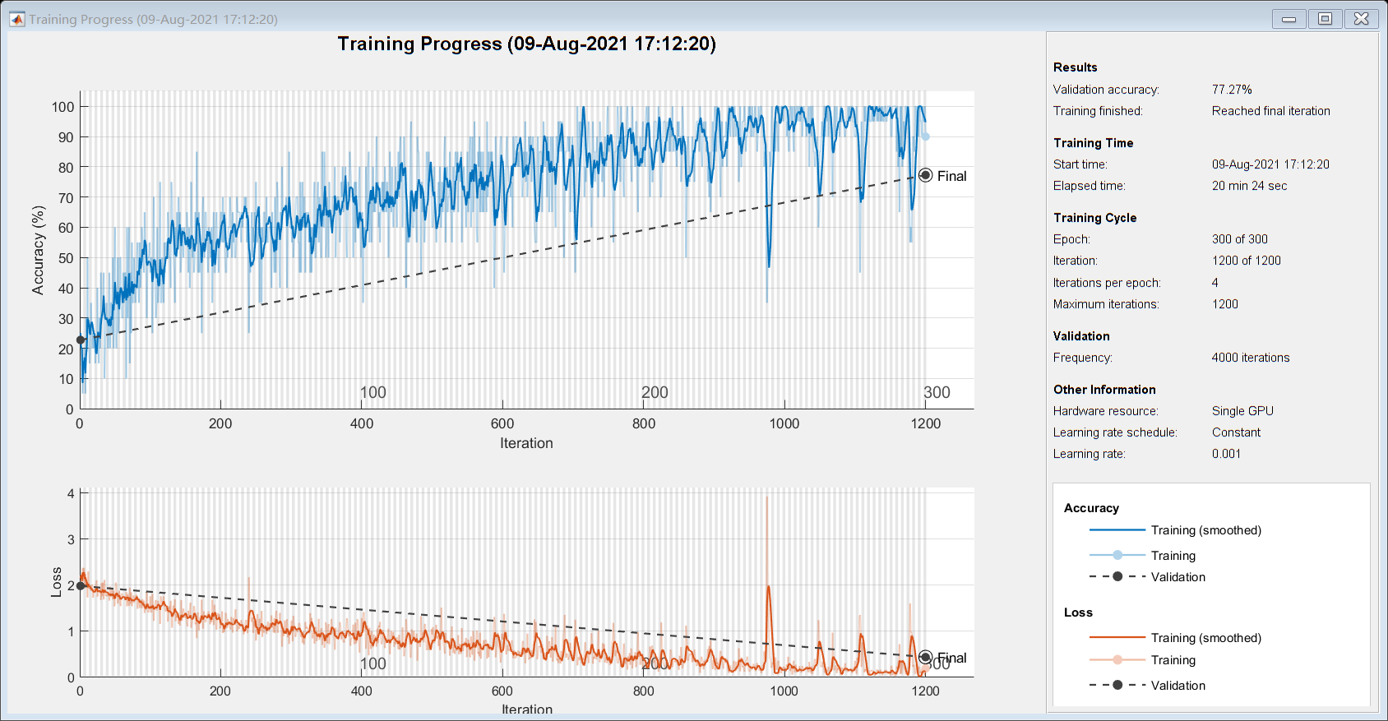

net =

[**DAGNetwork**](matlab:helpPopup%20DAGNetwork) with properties:

Layers: [144×1 nnet.cnn.layer.Layer]

Connections: [170×2 table]

InputNames: {'data'}

OutputNames: {'output'}

traininfo = struct with fields:

TrainingLoss: [1×1200 double]

TrainingAccuracy: [1×1200 double]

ValidationLoss: [1×1200 double]

ValidationAccuracy: [1×1200 double]

BaseLearnRate: [1×1200 double]

FinalValidationLoss: 0.4409

FinalValidationAccuracy: 77.2727